- Bluebook Page70 November 2018 variant one examination:

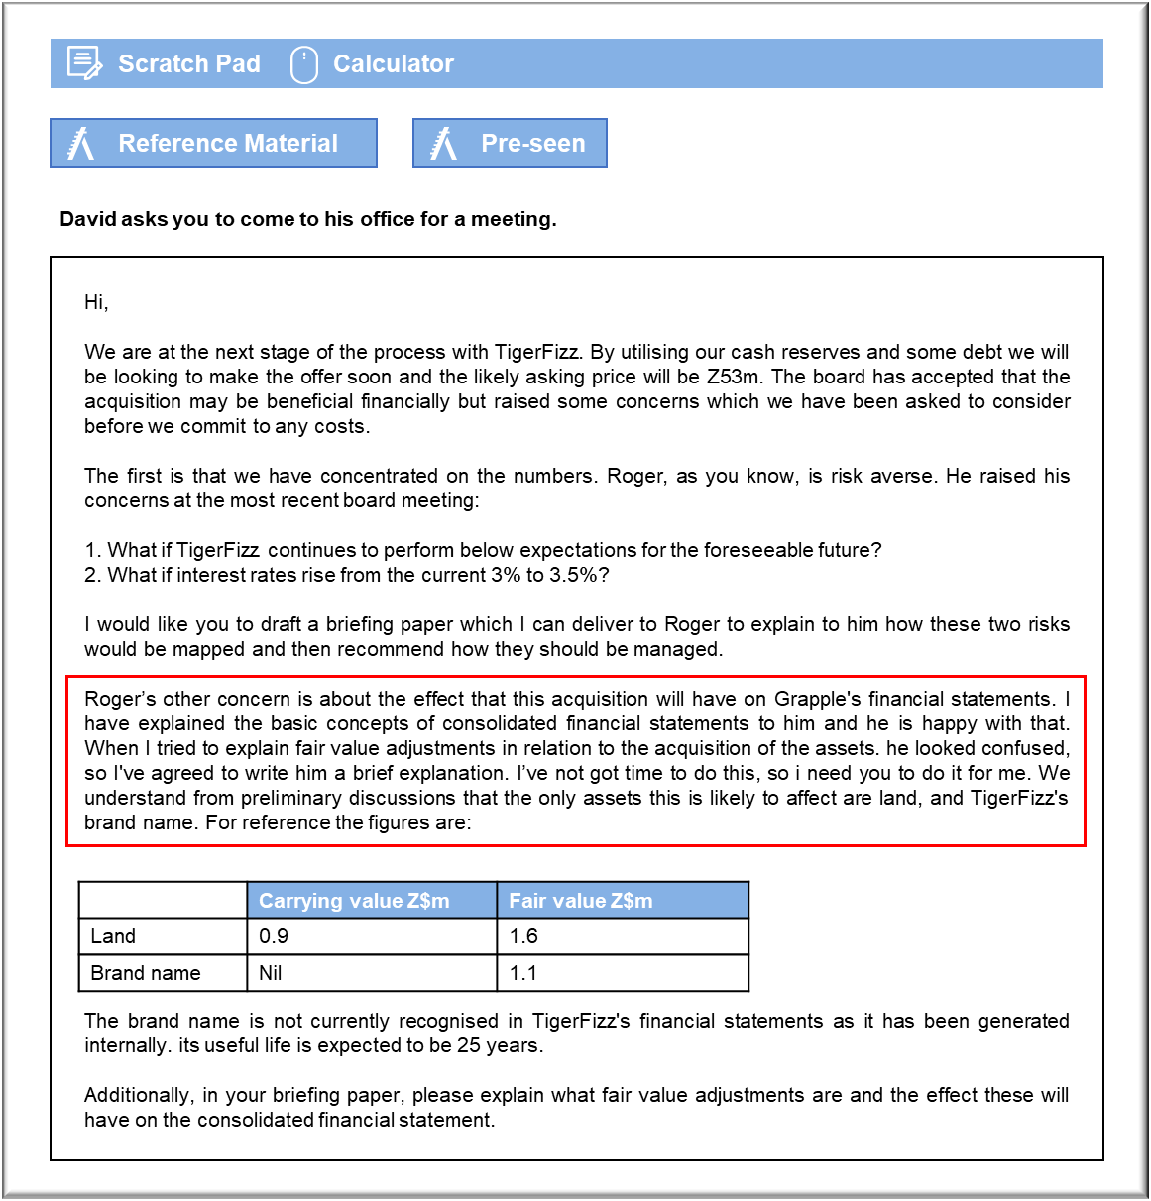

MANAGEMENT CASE STUDY NOVEMBER 2018 EXAM ANSWERS

Variant1 Task2
These answers have been provided by CIMA for information purposes only. The answers created are indicative of a response that could be given by a good candidate. They are not to be considered exhaustive, and other appropriate relevant responses would receive credit.

CIMA will not accept challenges to these answers on the basis of academic judgement.
Risk management
The risk map allows us to plot the risks and the likelihood of their occurrence on a
diagram and identify the suitable course of action. Risks with a substantial impact on the
business and with a high chance of occurring require urgent attention whereas those
with a lesser impact and lower chance of occurrence need less.
If the likelihood is high but the impact is low we should seek methods of reducing the
risk. Whereas if the likelihood is high and the effect is also high we should avoid the
risk, by perhaps not going ahead with the project.
If the likelihood is low and the impact high, we would try and share the risk or transfer it
to another entity using, say, insurance. If the likelihood is low and the impact is low we
may simply accept the risk.
Taking each risk mentioned in turn:
1. What if TigerFizz continues to perform below expectations for the foreseeable
future?
We have accepted that this is a substantial investment for us. If TigerFizz were to
fail this would have a significant impact on our results and possibly our ability to
continue trading. The likelihood of this happening is unknown. We would make
sure that we have reviewed the financial statements of the business carefully
before it is acquired. If, having done this, we find that the risk of failure is high,
because they may not make profits or that TigerFizz is not a good fit culturally,
then Grapple should 'avoid' and not acquire Grapple. If the likelihood is low, we
may be able to share the risks by suggesting that some of the consideration is
made conditional upon the future results of TigerFizz reaching a certain target.
2. What if interest rates rise from the current 3% to 3.5%?
0.5% is not a significant increase in interest rates when we consider that this
would be about Z$15,000 if the entire consideration was borrowed. The likelihood
is unknown, but we could research the economic forecast to help determine how
likely this is to happen. As the effect on the financial statements is not
substantial, we may well accept the risk, as long as there are no other concerns
about the profitability of the group.

Fair value adjustments
What are they?
According to the principles of consolidated financial statements using international
accounting standards, when a subsidiary is acquired its net assets are recognised at fair
value. The difference between the carrying value (the value of the net assets in the
subsidiary’s financial statements) and the fair value of the net assets (the market value)
on the date of acquisition are known as fair value adjustments. For TigerFizz, the
difference of Z$0.7 million (Z$1.6m - Z$0.9m) for the land and Z$1.1m (Z$1.1m - Z$nil)
for the brand name represent the fair value adjustments. The fact that the brand name
was internally generated by TigerFizz means that it will not be recognised as an
intangible asset in the single entity financial statements. As Grapple would be acquiring
the brand it would be recognised in the consolidated financial statements of the group.
When calculating goodwill on the acquisition of TigerFizz, Grapple will deduct the fair
value of the net assets from the consideration payable. The adjustments calculated here
are added to the current carrying value to create the fair value of the net assets.

The effect of fair value adjustments on the consolidated financial statements
The increase in the value of the net assets at acquisition from carrying value to fair
value will affect the consolidated financial statements in two ways:
• The value of goodwill is reduced from what it would have been had we calculated
it based on carrying values. This increases the value of land in the non-current
assets on the consolidated statement of financial position. In addition, there will
now be an intangible asset called Brand.
• The increase in the value of the brand that has a useful life of 25 years, will mean
that there is an amortisation charge made to the consolidated statement of profit
or loss will increase thus reducing the group profits in the post- acquisition
period. Land is not depreciated. The amortisation is Z$1.1m/25 years i.e.
Z$44,000. This is not a significant sum compared to the level of profits.
I trust this has answered your queries but if you have any further questions please just
ask.

